ORDER DETAILS WOMAN
Delivery Details
- Full Name:
- Address:

- Phone (Require for Delivery Service):
- Email:
- Deadline date (In case you have any competition or event with date exact):
- Model ordered:
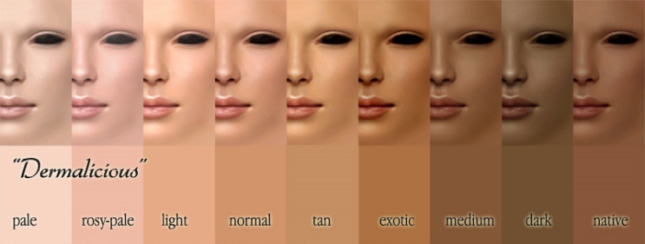
- Skin Tone (for taking the fabric of colour nude):
Measurements (Inches/Cm)
 | 01-Head Circumference
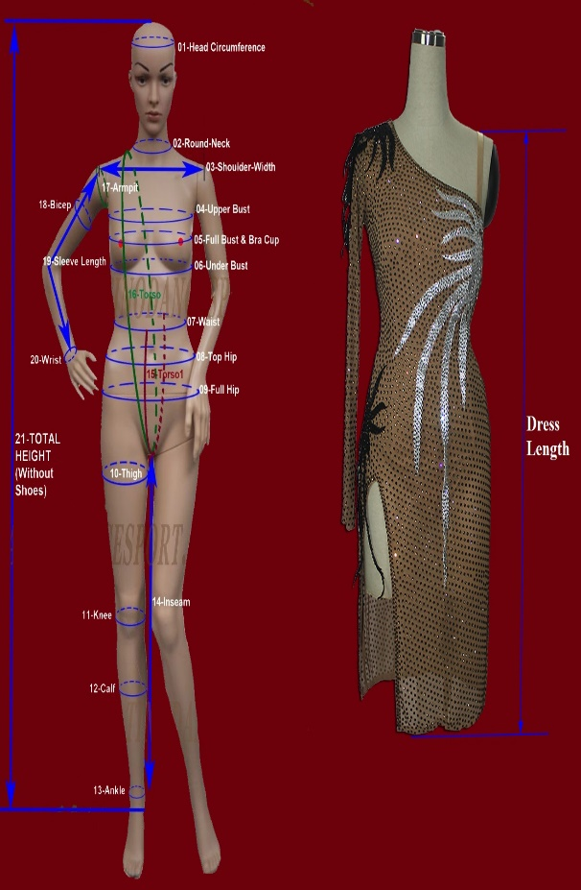 | 02-Neck Circumference (Round neck)
 | 03-Shoulder Width (Shoulder Point to Shoulder Point)
 | 04-Upper bust
 | 05-Full Bust & Bra cup (A, B, C, D….)
 | 06-Under Bust
 | 07-Waist
 | 08-Top Hips (at hips bone)
 | 09-Full Hips
 | 10-Thigh Circumference
 | 11-Knee Circumference
 | 12-Calf Circumference
 | 13-Ankle Circumference
 | 14-Inseam
 | 15-Torso1 (Front waist => the back waist-pass by crotch)
 | 16-Torso (side of front neck make a round pass by crotch to back upon the starting point)
 | 17-Armpit Circumference
 | 18-Bicep Circumference
 | 19-Sleeve length (shoulder point to wrist)
 | 20-Wrist Circumference
 | 21-Total height without shoes (How Tall)
 | 22-Length of Rhythm/Latin dress (Shoulder =>Stop Point)
 | 23-Length of Smooth/Standard dress (Shoulder =>Stop point)
If possible ,give me some of your pics(front-side-back) for me having a look of your body style, it will help me in cutting best suit your dress with your body style.

Colour
Give us your colours which you like with name and number in our colour chart (below) OR same original pic (we will take the nearest colour for you)
# …

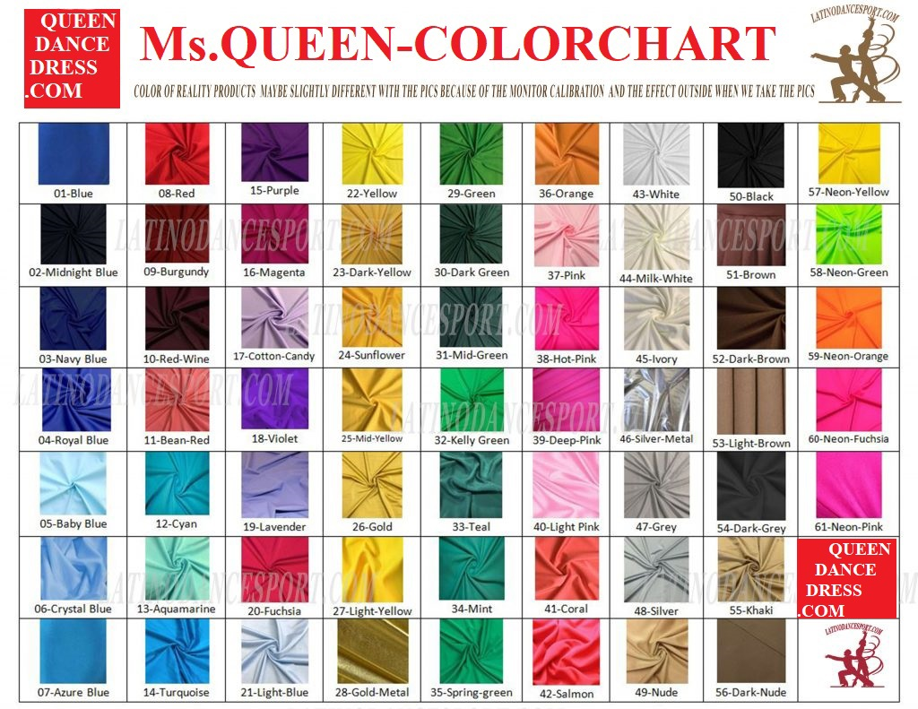
Note & Remark

