ORDER DETAILS MAN
Delivery Details
- Full Name:
- Address:

- Phone (Require for Delivery Service):
- Email:
- Deadline date (In case you have any competition or event with date exact):
- Model ordered:
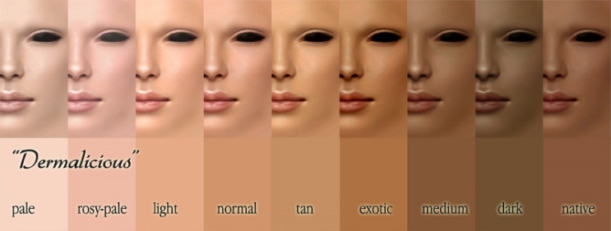
- Skin Tone (for taking the fabric of colour nude):
Measurements (Inches/Cm)
 | 01 | Neck Circumference (Round neck)
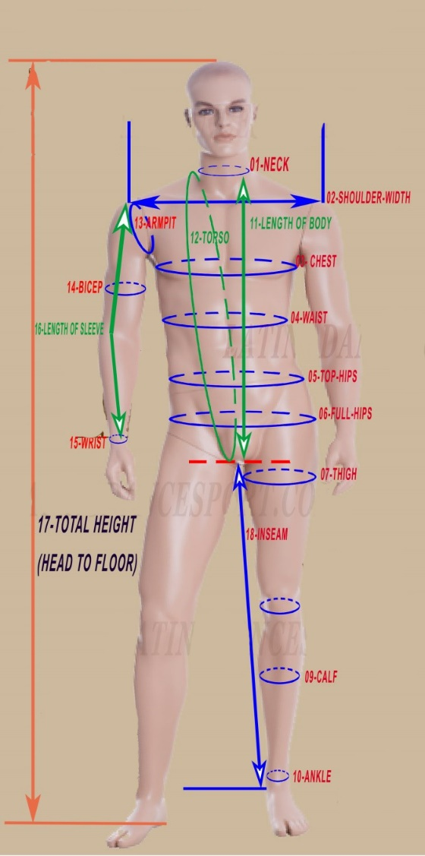 | 02 | Shoulder Width (Shoulder point to shoulder point)
 | 03 | Chest
 | 04 | Waist
 | 05 | Top Hips (at hips bone)
 | 06 | Full Hips
 | 07 | Thigh Circumference
 | 08 | Knee Circumference
 | 09 | Calf Circumference
 | 10 | Ankle Circumference
 | 11 | Length of Body
 | 12 | Torso (Start from side of front neck make a round pass by crotch to back upon the starting point)
 | 13 | Armpit Circumference
 | 14 | Bicep Circumference
 | 15 | Wrist Circumference
 | 16 | Sleeve length (shoulder point to wrist)
 | 17 | Total height without shoes
 | 18 | Inseam- Length of Leg
 |  | LENGTH OF SHIRT: Shoulder to longest point
 |  | Body Shirt with underpants or not | Yes/No
If possible ,give me some of your pics(front-side-back) for me having a look of your body style, it will help me in cutting best suit your dancewears with your body style

Colour
Give us your colours which you like with name and number in our colour chart (below) OR same original pic (we will take the nearest colour for you)
# …

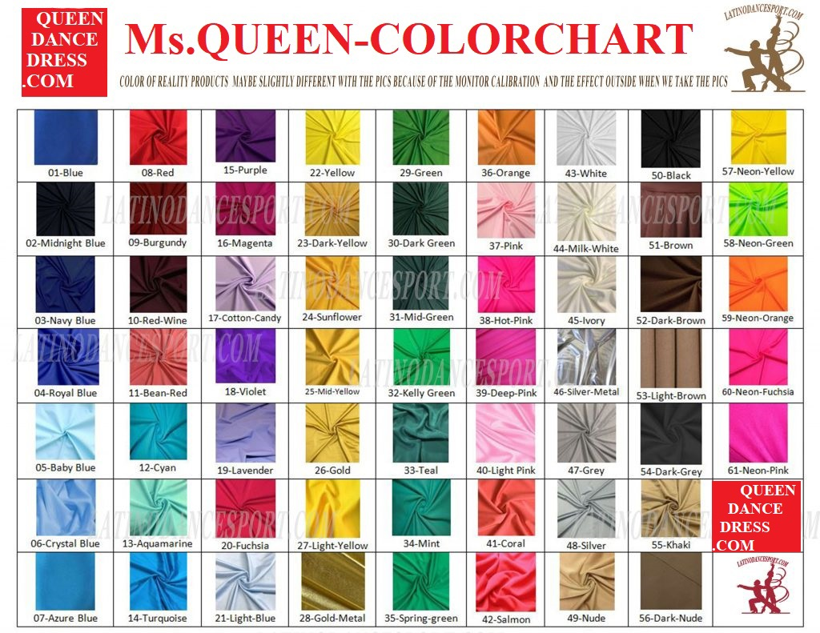
Note & Remark

