ORDER DETAILS
Shipping Details
Full Name:
Address:

Country:
Phone (Require for Delivery Service):
Email:
Deadline date (In case you have any competition or event with date exact):
Model ordered:
Skin Tone (for taking the fabric of colour nude):
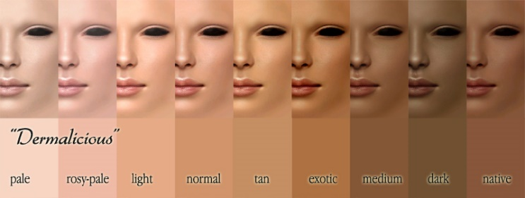
Measurements
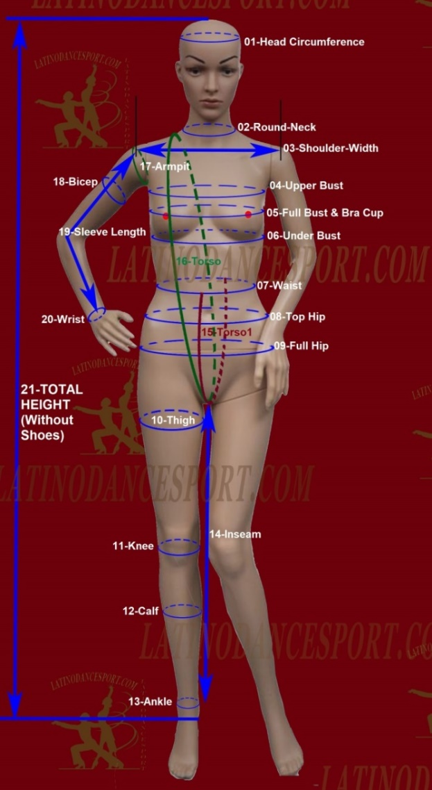 |  |  |  | Inches or cm
 | 01 | Head Circumference
 | 02 | Neck Circumference  (Round neck)
 | 03 | Shoulder Width (Shoulder point to shoulder point)
 | 04 | Upper bust
 | 05 | Full Bust & Bra cup (A, B, C, D….)
 | 06 | Under Bust
 | 07 | Waist
 | 08 | Top Hips (at hips bone)
 | 09 | Full Hips
 | 10 | Thigh Circumference
 | 11 | Knee Circumference
 | 12 | Calf Circumference
 | 13 | Ankle Circumference
 | 14 | Inseam
 | 15 | Torso1  (From the front waist to the back waist-pass by crotch)
 | 16 | Torso (start from side of front neck make a round pass by crotch to back upon the starting point)
 | 17 | Armpit Circumference
 | 18 | Bicep Circumference
 | 19 | Sleeve length (shoulder point to wrist)
 | 20 | Wrist Circumference
 | 21 | Total height without shoes
 | 22 | Length of Rhythm/Latin dress (from shoulder to the longest point)
 | 23 | Length of Smooth/Standard dress (from shoulder to the longest point)
COLOR

Give us your colors which you like with name and number in our color chart (Color Chart below)
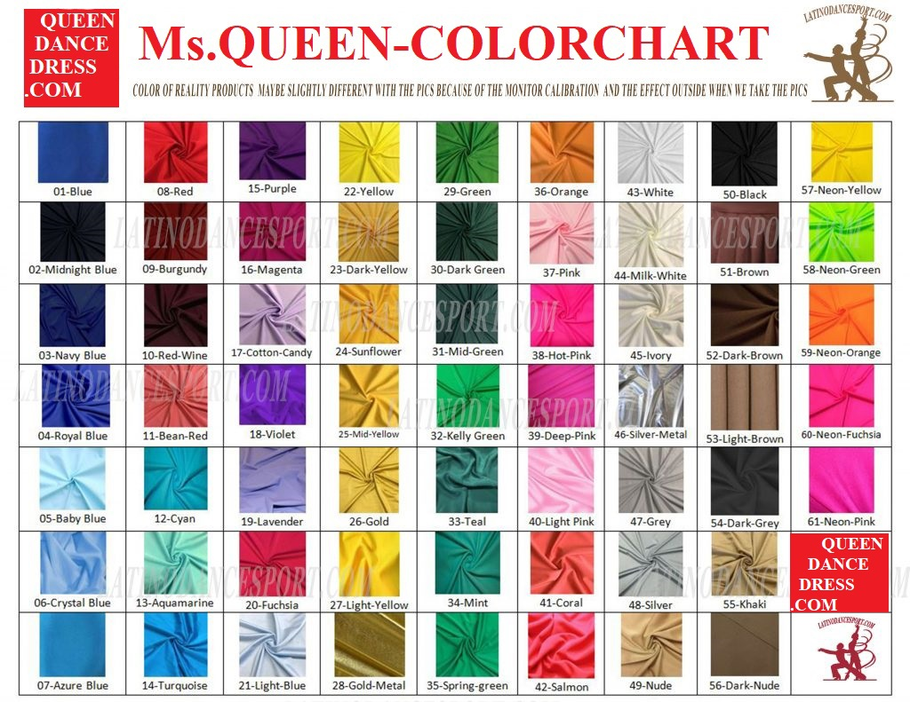
Other Note or Reminder

